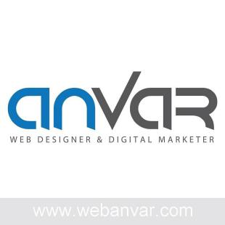Prince

Web Designer Dubai
Phone: +971 50 000 000
Address: Al-Karama, Dubai
Website: https://www.wenanvar.com
Email: prince@gmail.com

Proven graphic designing, logo designing, collaterals, Photography &amp; Photo Retouching experience. Familiarity with design software and technologies (such as Photoshop , Illustrator, indesign) , maya, 3ds max, After Effects, premiere etc. A keen eye for aesthetics and details Ability to work methodically and meet deadlines.

EXPERIENCE

National Institute of Speech and Hearing
Project Assistant
- Study design briefs and determine requirements
- Conceptualize visuals based on requirements
- Prepare rough drafts and present ideas
- Develop illustrations, logos and other designs using software or by hand

Kaleido Animations

3D Animator, 3D Modeler
- Working closely with the Director to achieve the same quality as needed for the project.
- Modelling the CG Characters, Backgrounds and props needed for the movie.
- Rigging the characters and the objects for the animators to animate flexibly and easily.
- Animating the characters and project according to the BG Score or dialogue.
- Finally rendering the scenes and checking all the props and the bgs are properly arranged.

Rocana Nigeria Ltd.

Graphic Head
- Prepares work to be accomplished by gathering information and materials.
- Plans concept by studying information and materials.
April 2010 - Jan 2012

Feb 2012 - Aug 2014

Nov 2014 - Sep 2015

- Illustrates concept by designing rough layout of art and copy regarding arrangement, size, type size and style, and related aesthetic concepts.
- Obtains approval of concept by submitting rough layout for approval.
- Prepares finished copy and art by operating typesetting, printing, and similar equipment; purchasing from vendors.
- Prepares final layout by marking and pasting up finished copy and art.

JD Fze

3D Designer
- To design 3D Jewelry Stands using Autodesk Maya, photoshop, illustrator etc.

Apr 2015 - Sep 2015

- To develop and manage 3D modelling, visualization and graphic design aspects of all projects based on the design requirements and deliver it with a creative artistic sense.
- Building Design in the design office and work closely with Manager and assigned projects leads/architects for respective projects.

The Elite Cars

Graphic Designer
- Developing concepts, Graphics and Layouts for Product Illustrations, Company Logos
- Excellent typography skills
- Creating digital assets including HTML email campaigns

Nov 2017 - Oct 2019

- Adobe Creative suites - Photoshop, Illustrator, Indesign skills
- Creating assets for the Social Media team, Gifs, Short videos & photoshoots
- Adopting each new store design creative and translating into a digital environment.
- Leading the brand narrative within digital campaigns
- Working closely with the Creative, Marketing, Social and SEO teams

EDUCATION
National Institute of Business Management
MBA in Mass Communication
Arena Animations
Diploma in Multimedia Animation

SKILLS

2014 - 2015

2007 - 2010

Creativity, Communication, Typography, Adobe Creative Suit, Branding, Print Design, Problem solving ability, Time management, Presentation, Interactive media, Adobe Photoshop, Indesign, illustrator, Graphic Design, Editing, 3D Design, Collaterals. Logo Designing

